Method
1 Building a protein
The majority of the project centers around creating the structure of the target protein using the template les found in the previous steps. Using a template structure and its alignment with the target we are able to confidently create a structure for the target which is close to native. After building a initial structure for the target, we use some existing tools to refine our model.

1.1 Algorithm - PDB to Structure
The structure is created by using an alignment file and a structure file to create a structure for the target. Under optimal circumstances there will be no difference in length between the target and template. However this is not always the case, so it is important to pad the front and back of the template's alignment and structure with blank residues. This is recorded as a single dash, -, in the alignment and a triple dash, |, in the structure. The structure is preprocessed and reduced down to a series of residues, each containing 4 atoms: N, CA, C, O. Residue names are changed from length 3 to length 1 so as to facilitate alignment checking between the template's alignment and structure.

1.2 Algorithm - Structure to PDB
Once the preprocessing is complete the alignment and structure can be used to create the target's structure. The basic idea is:
A) If the residue of the target is aligned with a residue of the template, copy its coordinates to the residue of the target.
B) If one residue of the target is blank in the alignment file, skip it and go on next one.
C) If the residue of the target is non-blank and the residue of the template is blank in the alignment file, create a blank residue for this target’s residue.

2 Optimization
Now, we have a candidate PDB file. However, there are still some important improvements to be made to our structure by third party tools.

2.1 MODELLER
First, there are still gaps in our protein where the two structures did not match. In these spots, our script generates matching protein data, but these atoms are simply generated and as such not part of the final protein. To combat this problem, we have modified our code slightly to output missing residues. Then, we use Modeller, a popular python tool in protein modeling, to re-optimize these residues so that they will match the rest of our protein.

2.2 SCWRL
Next, we run our candidate PDB file through SCWRL, a program for optimizing the side chains in our protein backbone. SCWRL4 is based on an improved graph theory algorithms that solve the combinatorial problem in side-chain prediction more rapidly than many other available programs.

SCWRL4 is based on a new potential function that results in improved accuracy at reasonable speed.It will converge on very large proteins or protein complexes or those with very dense interaction graphs.It depends on a backbone-dependent rotamer library. The library provides lists of chi1-chi2-chi3-chi4 values and their relative probabilities for residues at given phi-psi values, and explores these conformations to minimize sidechain-backbone clashes and sidechain-sidechain clashes.

The SCWRL4 executable saves the resolved optimal conformation of the whole protein model into PDB file. The corresponding value of the total energy is printed into the standard output, which can be redirected to a file for further analysis.

2.3 3DRefine
Finally, we used a two-step refinement protocol, called 3Drefine, to consistently bring the initial model closer to the native structure. One of the major limitations of computational protein structure prediction is the deviation of predicted models from their experimentally derived true, native structures. The first step is based on optimization of hydrogen bonding (HB) network and the second step applies atomic-level energy minimization on the optimized model using a composite physics and knowledge-based force elds. The approach has been evaluated on the CASP benchmark data and it exhibits consistent improvement over the initial structure in both global and local structural quality measures. 3Drene method is also computationally inexpensive, consuming only few minutes of CPU time to refine a protein of typical length (300 residues).

3 Visualization & Results
3. 1 Visualization
After we obtain our final target PDB file, we use Jmol to visualize it. At the same time, we also visualize the native one to compare it with our prediction. The left one is a target structure we generated (T0644), while right one is the native structure.

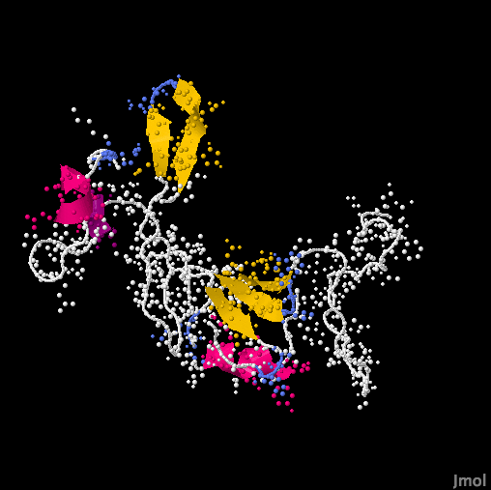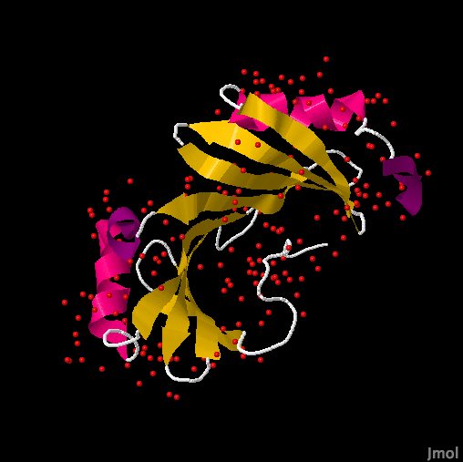

Figure 2: Target structure Figure 3: Native structure

3.2 Results
After we generate the target PDB file, we use TM-Score and RMSD to evaluate our prediction. Also, we compared our prediction with other servers' results based on same target. For our project, we choose MuFold and MULTICOM to provide a benchmark.

 | Group1 | MULTICOM | MUFOLD
TM-Score | 0.9971 | 0.9072 | 0.1985
RMSD | 0.23 | 1.666 | 14.978

